R. Reports Menu: 1. Marriage or Civil Union Listing (License Number)

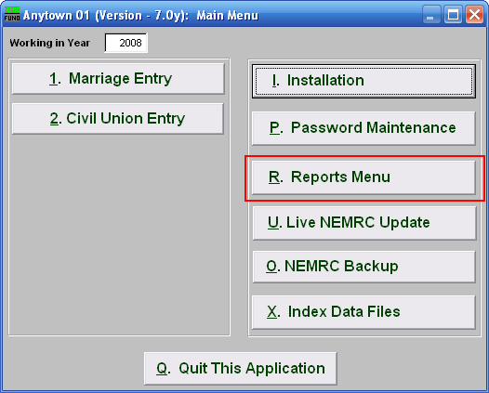
Click on “R. Reports Menu” from the Main Menu and the following window will appear:

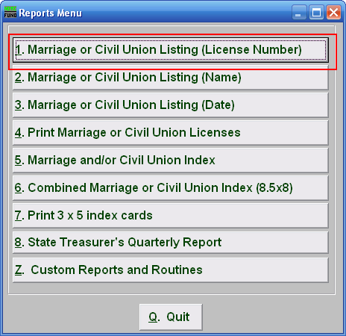
Click on “1. Marriage or Civil Union Listing (License Number)” from the Reports Menu and the following window will appear:

Marriage or Civil Union Listing (License Number)

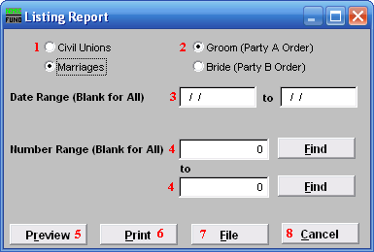
- Civil Unions OR Marriages: Click on the circle next to the Type you want the report to be on.

- Groom (Party A Order) OR Bride (Party B Order): Choose how you want the report to print: by Groom (Party A) Order or by Bride (Party B) Order.

- Date Range (Blank for All): Enter the date you wish to start with and the date you wish to end with. Leave blank for all.

- Number Range (Blank for All): Enter the License Number you wish to start with and the License Number you wish to end with OR click on “Find” to select from the list. Leave blank for all.
.
- Preview: Click this button to preview. Refer to GENERAL PREVIEW for more information.

- Print: Click this button to print. Refer to GENERAL PRINTING for more information.

- File: Click this button to save on this computer. Refer to GENERAL FILE for more information.

- Cancel: Click this button to save on this computer. Refer to GENERAL FILE for more information.

